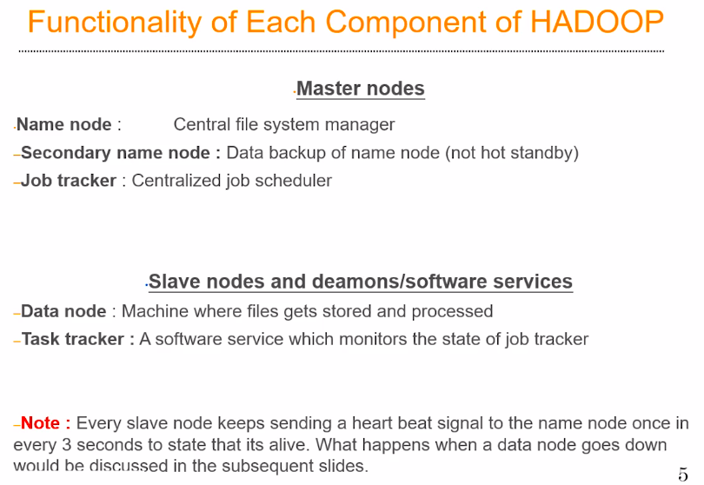

Hadoop is a parallel processing framework, so if you want to do some parallel processing we need to have a distributed file system.

Hadoop has its own built in distributed file system which is called as HDFS, which we’ll discuss in detail later.

So, HDFS is the one which saves the file in multiple data nodes. So, when we push a file into a hadoop cluster,will be split into smaller blocks and these block will be sent to the data nodes.

So the name node is going to remember:
- Who was the person who pushed the file?
- What is the size of these file?
- How many blocks this file has been broken down into?
- Which of the data nodes, these file is actually residing?

All the information is present in the name node in the form of file table. So the Name node is the centralized file server. Note: Name node is not saving any files. All the files are getting saved in the data node. Name node simply remembers, where exactly on the data nodes the files are stored.

Secondary Name Node, maintains the backup of whatever is present in the name node. So in the event of a name node failure, somebody has to manually fix the issues in the name node and back up all these files from the secondary name node and copy it back to the name node. This is the case in Hadoop version 1, However this is fixed in Hadoop version 2 where a name node actually has hot-stand by name node. That we will discuss later in Hadoop Version 2.

Data Node: It is a place where the data where the data is actually going to get stored and where the actual processing is going to happen.

Task Tracker: It is a software services, In computer science terminology, this is called as software daemons, or background processes. Which keeps running on every single data node. One per data node, where it keeps track of the activities happening on the data node and reports the status to the job tracker.

NOTE:
- Name node and Secondary Name node pretty much actually has the same kind of hardware configuration, they need to be very high on ram and they need to be very low on hard-drive. They don’t need anything more that a few Terabyte of hard-drive space space. Even one terabyte space would be sufficient. And in terms of CPU computational capacity, your name node and secondary name node need not be very very powerful, even a quad core or an octa-core cpu would do the job.

- Where as your Job Tracker needs to be much more powerful than your name node and your secondary name node in terms of computational capacity. Probably, your job tracker can have 16 core or 32 core cpus and probably 50 Gbs of ram. And your job tracker may not need a very high amount of hard-drive storage as well. Probably one or two TB will be enough.

However, This is a weird architecture, because here the Slave nodes are very much powerful than the Master nodes, In terms of Hardware Infrastructure. For example, Data Node should have at least 16 CPU cores, The industry typically uses 32, 64, or 128 CPU cores for a Data Node and also depending on the budgeting. And the amount of ram is ranges between 100 to 200 Gbs of Ram per data node. And hard-drive is in between the range of 50 – 100 Tbs of Storage. So, the data node is very powerful as compared to the master nodes ( Name node, secondary name node and Job Tracker)

Every data node needs to be communicating with the master node by sending a heart beat signal, once in every 3 seconds, so, if a data node fails to actually send a heartbeat to their master node once in 3 seconds, It’s assume that something is wrong with them, assumed as dead, this would actually trigger a system wide alarm and the administrator has to go and resolve the issues.

